
Story

Date | 26 October 2026
Team ID | Individual
Project Name | Electric Vehicle Market Analysis Dashboard
Maximum Marks | 5 Marks

By using stories in Tableau, you can effectively communicate complex data in a way that is both interactive and engaging, making it easier for the audience to follow along and understand the insights. It’s a tool for data storytelling, allowing you to present insights in a cohesive, engaging way that takes viewers through a logical progression of findings or analyses.
In Tableau, Story is a feature that allows you to create a sequence of dashboards, visualizations, and text to present data insights in a cohesive and narrative-driven way. It's like a slideshow within Tableau that guides the audience through a series of data points, helping them understand key insights, trends, or outcomes of your analysis.

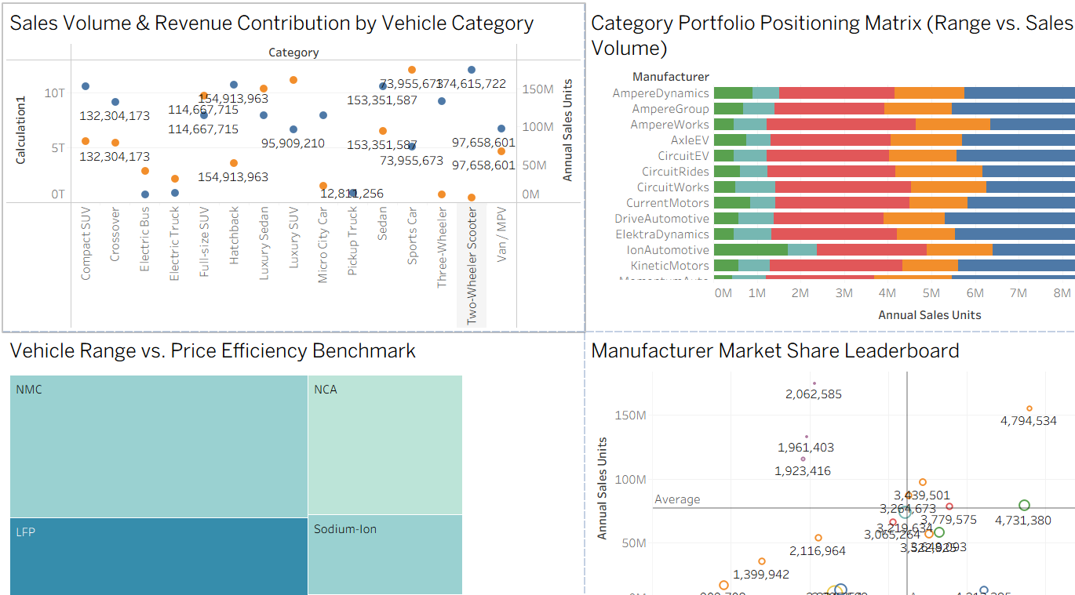
Story Point 1: Market volume, portfolio positioning and manufacturer share
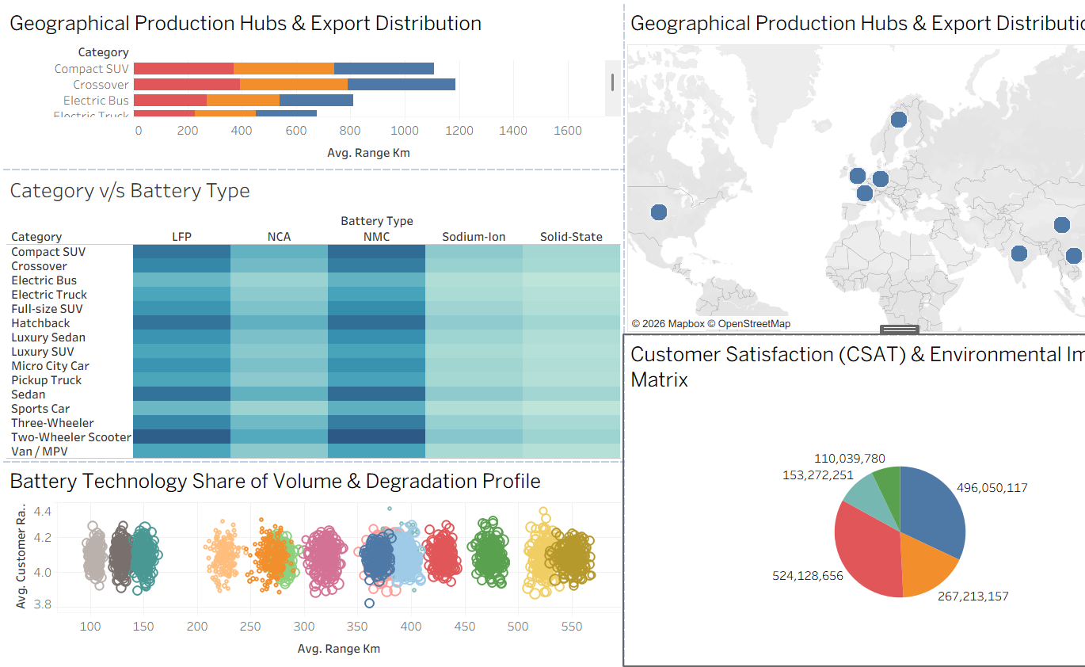
Story Point 2: Production hubs, battery technology and customer satisfaction

Observations:
- Two-Wheeler Scooters Lead Volume: The Two-Wheeler Scooter category records the highest labelled sales volume at about 174.6M units.
- Sales Concentrated in Two Segments: The two largest segments contribute about 65.8% of the roughly 1.55B total annual sales units.
- NMC and LFP Dominate Battery Mix: NMC and NCA hold the largest tiles in the range vs price treemap, and LFP and NMC are the most prominent battery types across vehicle categories.
- Crossovers and Compact SUVs Offer the Longest Range: Crossover (about 1,180 km) and Compact SUV (about 1,100 km) lead on average range among the visible categories.
- Satisfaction Stays Stable Across Technologies: Average customer ratings remain between 3.8 and 4.4 even as average range varies from about 100 to 550 km across battery technologies.

Activity 2:
Publish Story on Tableau Public and Paste Public link below
[Paste your Tableau Public story link here after publishing]

